**Investigation of influence of infill nature on spatial temperature distribution from an artificial temperature gradient obtained in fused deposition modeling**

October 16th, 2018

Pranav Addepalli

**Problem**

How does infill nature of a 3D printed object influence spatial temperature distribution, and can it help reduce warpage in 3D printing?

**Hypothesis**

If various combinations of infill percentage and types are printed, then there will be a strong, positive correlation between the infill percentage and temperature distribution because conduction is a far more effective form of heat transfer than radiation, increased infill percentage increases the amount of plastic and the density of the object, thereby increasing the temperature distribution.

Additionally, a hexagonal infill type will have the most even temperature distribution because it has the more pathways for heat transfer.

**Independent Variable**

The infill used to 3D print an object. Three infill types will be tested: hexagonal (honeycomb), triangular, and rectilinear. The five infill percentages to be tested are 10%, 20%, 30%, 40%, and 50%. All combinations of these infill types and percentages will be tested for a total of 15 changes of the independent variable.

**Dependent Variables**

The spatial temperature distribution and thermal conductivity of the object is the dependent variable in this experiment. It can be split into the horizontal and vertical components. The horizontal temperature distribution will be directly found by calculating the object’s temperature at ½ second intervals during the printing and cooling process using thermistor voltage measurements and the Steinhart-Hart Equation (Equation 1),

(1)

$$\frac{1}{T}=A+Bln\left(R\right)+C{[ln\left(R\right)]}^{3}$$

where *T* is the temperature in Kelvin, *R* is the resistance in ohms, and *A*, *B*, and *C* are the Steinhart-Hart coefficients that are constant to specific thermistors**.**

The thermal conductivity of the object will also be measured to give a vertical indication of the temperature distribution. It will be calculated using an adapted Lees’ Disc apparatus (Figure 1) and Equation 2,

(2)

$$kA\frac{\left(T_{2}-T_{1}\right)}{x}= mC\frac{dT}{dt}$$

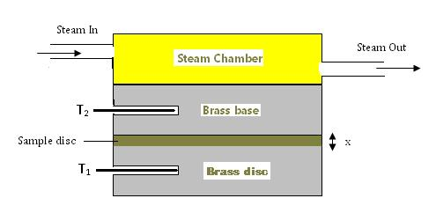where *k* refers to the coefficient of thermal conductivity, *A* refers to the surface area of the object in contact with the metal disc in the Lees’ Disc apparatus, *T2* refers to the temperature of the lower metal disc, *T1* refers to the temperature of the upper metal disc, *x* is the thickness of the object, *m* is the mass of the metal disc, *C* is the specific heat capacity of the metal, and $\frac{dT}{dt}$ is the rate of cooling of the metal disc at temperature *T2*.

**Figure 1:** *Diagram for Lees’ Disc Method.*

**Constants**

The constants in this experiment will be the material used (Hatchbox 1.75mm PLA), the3D printer used (Series 1 Pro Type-A Machine), the printer settings (extruder temperature of 205°C for first layer and 200°C for the rest; bed temperature of 65°C for the first layer and 60°C for the rest; the layer thickness and height; and 3 perimeters for the bottom layer and 4 for the top layer), the time span tested (0.5 second intervals from thermistor placement to 2 minutes after print completion), the type of NTC thermistor used, and the parts and steps of the Lees’ Disc apparatus and method for thermal conductivity measurements.

**Control**

There is no control in this experiment because the measurements of temperature distribution from each of the 15 infill combinations will be compared to each other.

**Repeated Trials**

There will be five trials of each of the 15 infill combinations for a total of 75 trials.

**Materials**

* Hatchbox 1.75mm PLA filament (SDS: ultimaker.com/download/13078/SDS%20PLA.pdf)
* Series 1 Pro Type-A Machine 3D printer
* 750 Glass encapsulated 200K Ohm NTC thermistors (TH420J34GDNI) from Amphenol Advanced Sensors
* Resistors and wires
* Arduino Uno R3
* Computer
* Vernier Logger Pro
* Lees’ Disc Apparatus (will be constructed using the following)
  + Brass
  + Aluminum
  + Steam generator (Earlex SS77USSG 1.3 gallon tank)
  + Vernier temperature probes
  + Ring stands

**Procedure**

***Phase 1: Equipment Setup***

1. Throughout any manufacturing or testing procedures, safety glasses, boots, and gloves will be worn.
2. I will set up an Arduino temperature sensor using thermistors, program it correctly, and test the sensor.
   1. Wearing an anti-static wristband, the temperature sensor will be connected through a voltage divider circuit, shown in Figure 2.

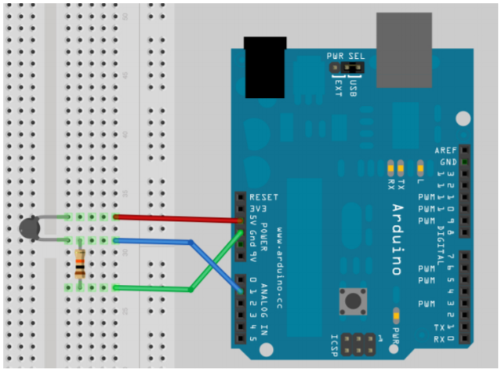

Thermistor

Resistor

Arduino Uno R3

**Figure 2:** *Diagram for a Voltage Divider circuit and sample breadboard wiring for thermistor resistance calculations.*

* 1. The temperature will be calculated using an Arduino program based on Equation 3, a modification of the Steinhart-Hart relationship, where *T* is the thermistor temperature in Celsius; *TA*, *TB*, and *TC* represent the thermistor alpha, beta, and gamma coefficients respectively; *R0* represents the fixed resistance in the circuit, and *V* represents the analog thermistor reading.
 $$T=\frac{1}{T_{A}+\left[T_{B}\ln\left(R_{0}\left(\frac{1024}{V}-1\right)\right)\right]+\left[T_{C}\ln^{3}\left(R_{0}\left(\frac{1024}{V}-1\right)\right)\right]}-273.15$$

 2. The temperature sensor will be tested by running the program, recording the calculated temperature values, and comparing these values with actual thermometer temperature measurements.

1. I will use Fusion 360 CAD software to create models for the 15 different infill combinations.
   1. Each combination will be designed with 9 compartments for thermistor placement and small channels leading outside of the disc. Each thermistor will be placed at 1 inch intervals throughout the entire 8 inch diameter disc.
   2. Each combination will have a radius of 4 inches and a thickness of 0.5 inches.
2. I will also CAD and manufacture an adapted version of the Lees’ Disc apparatus design in Figures 1 and 3.

**Figure 3:** *Diagram of Lees’ Disc Apparatus.*

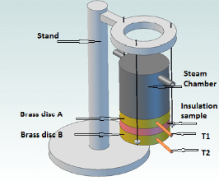

* 1. Safety equipment from Step 1 will be worn.
  2. Two brass discs of ½ inch thickness and 4 inch radius will be cut.
  3. Four ¾ inch holes will be machined into one of the brass discs at 90° angles as shown by Figure 4. Bolts of a ¼ inch diameter will be inserted into the holes such that the bolt head protrudes from the brass disc.

Brass disc

Bolt heads

**Figure 4:** Diagram of holes to be machined for a brass disc.

* 1. Two identical holes will be machined into the discs to insert the Vernier temperature probes. Thermal grease will be used to fill up any air gaps.
  2. A closed aluminum cylinder will be cut and manufactured with a capacity of approximately 1.3 gallons (6 inch height, 4 inch radius) to use as a steam chamber. Holes with the diameter of the steam generator hose will be machined into the chamber to act as a steam input and output.
  3. 4 pieces of rope/cord with the same length will be attached to the protruding bolts in one of the brass discs and tied to the ring stands to suspend the brass disc.
  4. The steam generator, chamber, and other brass disc will be held for later use.

1. The Lees’ Disc will be tested using cardboard, which has an approximate thermal conductivity of 0.21 W/mK.
   1. Safety equipment from Step 1 will be worn.
   2. A 4-inch radius cardboard sample’s thickness will be measured using a Vernier caliper.
   3. The sample will be placed on the suspended brass disc, followed by the second brass disc, followed finally by the steam chamber as shown in Figure 3.
   4. The steam generator will be turned on and left on until the system reaches a steady-state temperature (which will be defined as no net change greater than 0.5°C in 10 minutes.) The temperature of both probes T1 and T2 will be recorded.
   5. The sample will be removed and the new system, shown in Figure 5, will be allowed to rise above the steady-state temperature *T2* by approximately 10°C.

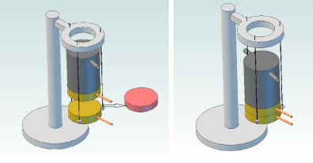

**Figure 5:** Lees’ Disc apparatus after sample removal.

* 1. The steam chamber will then be removed and the steam generator will be turned off.
  2. Immediately after, some insulating material will be placed on the area of the brass disc previously covered by the steam chamber.
  3. Once the brass disc cools and approaches *T2*, temperature will be recorded at 5 second intervals, and a cooling curve will be created for the lower brass disc based on this data.
  4. The derivative of the cooling curve at *T2* represents the $\frac{dT}{dt}$ term in Equation 5, and using this equation, the thermal conductivity of the cardboard can be calculated and compared to the actual value.

***Phase 2: Testing***

1. Safety equipment in Phase 1, Step 1 will be worn.
2. To find horizontal temperature distribution, the discs designed in Phase 1, Step 2 will be 3D printed and thermistors placed into the discs while printing.
   1. While the disc is printing in accordance with the CAD model, 9 pre-assembled thermistor-and-wire combinations will each be placed into a compartment and channel.
   2. The compartment and channel will be about 2 PLA layers above the print bed so that the thermistors are able to capture much of the data but are also still encompassed in the discs.
   3. The wires will be led out of the disc, print bed, and printer area and connected to an Arduino voltage divider circuit assembled in Step 1 of Phase 1.
   4. Extreme caution must be taken during Phase 2, Step 2.2 by not touching the print in order to prevent external modification of the print and temperature as well as to prevent burns.
   5. The program will begin to read the thermistor outputs and calculate temperatures in ½ second intervals until 2 minutes after the disc has been completed to collect cooling data as well.
   6. The disc will then be removed from the print and tested using a process similar to Phase 1, Step 4, the only difference being that the sample is the PLA disc, not cardboard, to calculate its thermal conductivity.
3. This process will be repeated five times for each of 15 individual infill combinations for a total of 75 trials.
4. A simulation of the heat flow and temperature distribution will also be run using AutoCAD software for each of the infill models.

**References**

Armillotta, A., Bellotti, M., & Cavallaro, M. (2018). Warpage of FDM parts: Experimental tests and analytical model. Robotics and Computer-Integrated Manufacturing, 50, 140-152. doi: 10.1016/j.rcim.2017.09.007

G. Recktenwald, “Temperature Measurement with a Thermistor and an Arduino,” Pdx.Edu, 2013.

Sombatsompop, N. & Wood, A. K. (1997). Measurement of thermal conductivity of polymers using an improved Lee’s Disc apparatus*. Polymer Testing*, *16*, 203-223. doi:10.1016/S0142-9418(96)00043-8

**Statistics**

**Pranav Addepalli**

1. The coefficient of thermal conductivity values based on infill type and percentage will be measured using a Lees’ Disc apparatus and method.
2. The coefficient of thermal conductivity values for each infill combination will be compared to one another with respect to two factors: infill type and infill percentage.
3. There are no controls in this experiment because the data is being compared within itself and because there is no known/expected data set for any of the infill percentages or infill types.
4. Each variation of infill type and percentage will be printed five times. The entire project will only be run once because there are already five trials of each of the infill combinations and the nature of the experiment, a study of distribution across various infills, does not need repeated data collection. Additionally, the lack of time to print and test 75 objects (of 15 different types) forces this experiment to only be ran once.
5. The data is inherently randomized and therefore does not need to be manually randomized.
6. The thermal conductivity data set will be organized into three tables. The following table is for all collected data

|  |  |  |  |  |
| --- | --- | --- | --- | --- |
| **Infill %** | **Trial** | **Rectilinear** | **Triangular** | **Hexagonal** |
| **10%** | **1** |  |  |  |
| **2** |  |  |  |
| **3** |  |  |  |
| **4** |  |  |  |
| **5** |  |  |  |
| **20%** | **1** |  |  |  |
| **2** |  |  |  |
| **3** |  |  |  |
| **4** |  |  |  |
| **5** |  |  |  |
| **30%** | **1** |  |  |  |
| **2** |  |  |  |
| **3** |  |  |  |
| **4** |  |  |  |
| **5** |  |  |  |
| **40%** | **1** |  |  |  |
| **2** |  |  |  |
| **3** |  |  |  |
| **4** |  |  |  |
| **5** |  |  |  |
| **50%** | **1** |  |  |  |
| **2** |  |  |  |
| **3** |  |  |  |
| **4** |  |  |  |
| **5** |  |  |  |

Five of the following tables will be created for each infill percentage to analyze in inStat:

|  |  |  |  |  |
| --- | --- | --- | --- | --- |
| **Infill %** | **Trial** | **Rectilinear** | **Triangular** | **Hexagonal** |
|  | **1** |  |  |  |
| **2** |  |  |  |
| **3** |  |  |  |
| **4** |  |  |  |
| **5** |  |  |  |

Three of the following tables will be created for each infill type to analyze in inStat:

|  |  |  |  |  |  |
| --- | --- | --- | --- | --- | --- |
| **Trial** | **10%** | **20%** | **30%** | **40%** | **50%** |
| **1** |  |  |  |  |  |
| **2** |  |  |  |  |  |
| **3** |  |  |  |  |  |
| **4** |  |  |  |  |  |
| **5** |  |  |  |  |  |

1. A parametric Two-Factor Analysis of Variation (ANOVA) with Replications test will be run on the overall data set because there is a single measurement variable and two factors, infill percentage and type, and five trials of data.